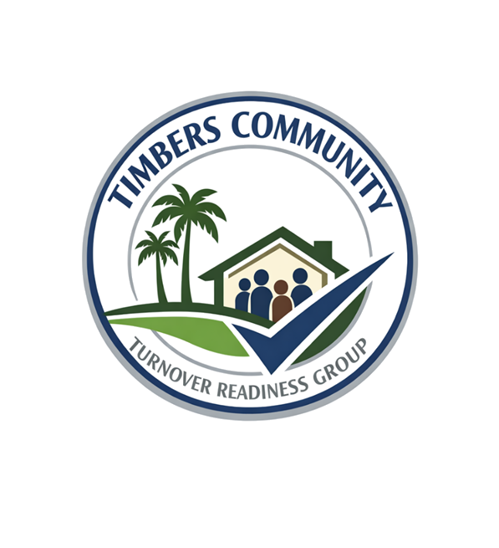
WE ARE STRONGER TOGETHER
If you would like to join any of these committees below, please complete the Subcommittee Volunteer Form.

Governance and Legal Committee
• Ability to read and understand documents (bylaws, covenants, policies)
• Interest in rules, fairness, and how decisions are made
• Comfortable summarizing information in plain language
Financial Review and Budget Committee
• Basic understanding of budgets, expenses, or accounting
• Attention to detail with numbers and reports
• Ability to ask practical questions about spending and reserves
Infrastructure and Transition Inspection Committee
• Background or interest in construction, engineering, or property maintenance
• Ability to understand, observe, and document physical issues (roads, drainage, etc.)
• Detail-oriented with a practical problem-solving mindset
Covenants, Compliance, and ARC Prep
• Strong sense of fairness and consistency
• Ability to interpret rules and apply them reasonably
• Good communication skills when explaining guidelines to neighbors
Vendor and Contracts Review Committee
• Experience reviewing contracts or service agreements (or willingness to learn)
• Ability to evaluate quality vs. cost
• Comfortable comparing options and asking vendors the right questions
Amenities and Lifestyle Committee
• Interest in community activities, amenities, and overall resident experience
• Observational skills (what’s working vs. what needs improvement)
• Creative thinking for events, usage, and improvements
Communications and Community Engagement Committee
• Strong written and/or verbal communication skills
• Comfortable using email, social media, or newsletters
• Ability to present information clearly and without bias
Election and Transition Planning Committee
• Organized and detail-oriented
• Interest in process, timelines, and fairness in elections
• Ability to explain procedures clearly to homeowners

